Level 29 -> Level 30

The goal of this level is to access **a git repository at ssh://bandit29-git@localhost/home/bandit29-git/repo.** The password for the user bandit29-git is the same as for the user bandit29. We need to clone the repository at our local computer and find the password for the next level.

This level is same as level 28,29. Follow first three steps of level 28/29.

Steps to follow after completing first three steps:

1. Check the files present in repo.
2. README.md file is present. When we cat README.md file we found a text which shows the username as bandit29 and password as <no password in production!>

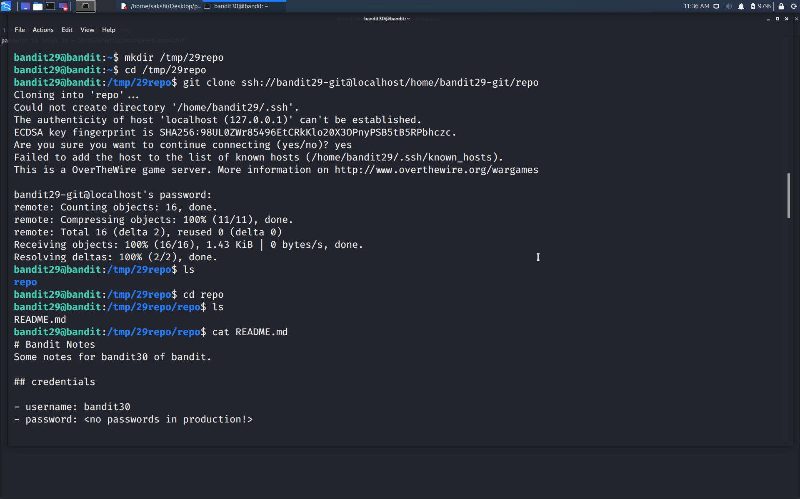

1. **Use git show** command to display objects like blobs, trees, tags and commits. We may find something in them. But using this we again did not find anything.

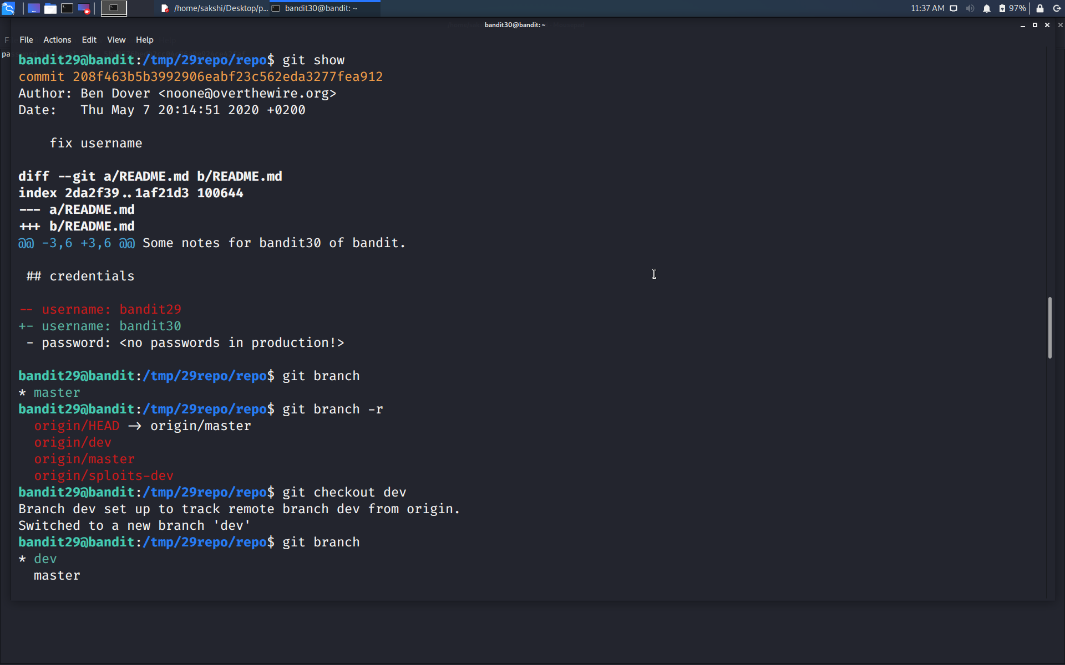

1. Git repositories can have multiple branches. So, check for the branch using **command git branch** **-r** if any. Before that check the current branch using **command git branch**.



1. Yes!!! This repository contains branches. Change the branch using **the command git checkout branch_name(to which we want to switch)**.
2. Use git show command to display objects like blobs, trees, tags and commits in this new branch.
3. And yes, here the password is.

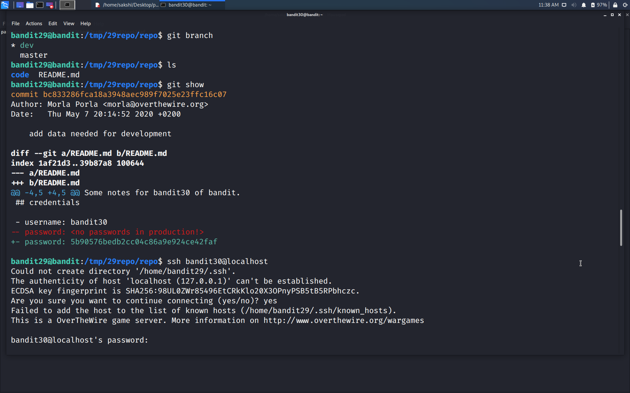

Use the command **ssh bandit30@localhost** to connect to the level 30.

Enter the password and hit enter.

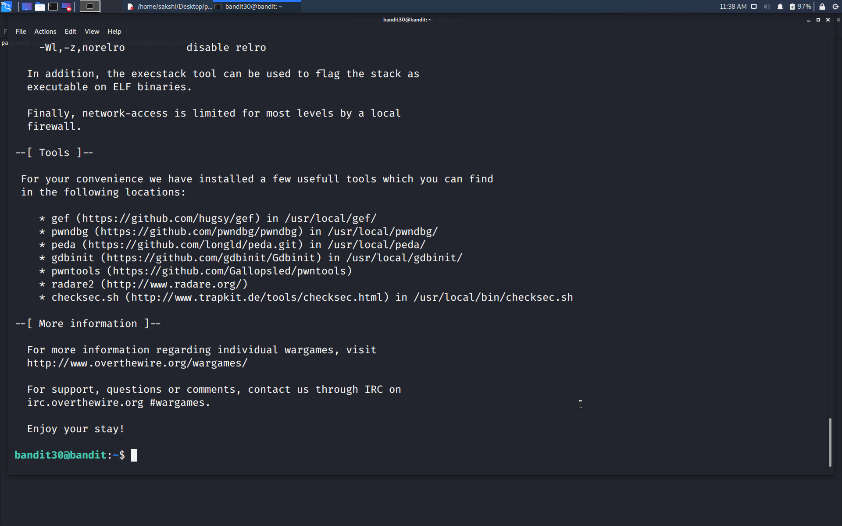

Successfully passed level 30.…